**2016 International Competitions and Assessments for Schools (ICAS)**

1st March, 2016

Dear Parent/Carer,

Learning is lifelong. However, now is the time your child most needs you to help them learn, grow and reach their full potential, and ICAS can help you do this.

The International Competitions and Assessments for Schools (ICAS) is an independent, quality skills-based assessment program which rewards and recognises achievement. ICAS gives you broad insights into your child’s performance across English, Mathematics, Science, Digital Technologies, Spelling and Writing. ICAS (sometimes referred to as the UNSW assessments) has been developed by Educational Assessment Australia (EAA) since 1981.

When your child takes part in ICAS assessments, we can track their learning as they progress from year to year. It also helps us identify potentially gifted students and those who may need more focused and purposeful teaching to achieve their best.

**Each student receives:**

* an engaging and challenging full-colour test booklet
* an individual diagnostic report highlighting strengths and weaknesses and year to year progression
* login details to access their online results which can be analysed and downloaded
* a High Distinction, Distinction, Credit, Merit or Participation Certificate acknowledging their level of achievement
* the chance to receive an individually-engraved UNSW medal for the highest scoring student in each year level for each subject.

**Help your young ‘spelling bee’ succeed**

The early years set the stage for lifelong learning. From 2016, Year 2 students will be able to sit an ICAS Introductory Spelling paper. This paper will help your little ‘spelling bee’ succeed by measuring their spelling ability and, importantly, identifying very early in their schooling where your child may need some extra help. **This paper is the only Spelling paper available in advance of Year 3 NAPLAN testing.**

To learn more about ICAS go to [www.eaa.unsw.edu.au/icas/about](http://www.eaa.unsw.edu.au/icas/about) Remember, EAA has some very helpful tools to help your child prepare. You can access practice assessments at www.eaa.unsw.edu.au/icas/preparation

**IMPORTANT: Children in Year 6 who wish to be considered for the Dux, English and /or Maths awards must sit the relevant tests (Spelling, Maths, Writing, and English). If you require financial assistance, please see Mr McGillicuddy.**

**To enrol your child in ICAS, please complete the registration form overleaf and return it, with your entry fees, to the school no later than March 31st. PLEASE NOTE NO LATE ENTRIES WILL BE ACCEPTED**.

Kind regards,

Marrion Woodhouse

School Administrative Officer

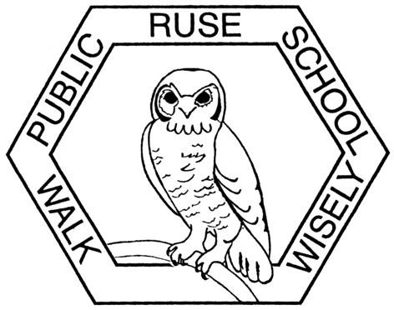**2016 International Competitions and Assessments for Schools (ICAS)**

**Permission Form**

**Please return this form to your child’s school**

|  |  |  |
| --- | --- | --- |
|  | of |  |

I give permission for my child­­­­­­­­­­­­­­­­­­­­­­, *Child’s name Class*

to participate in the following 2016 International Competitions and Assessments for Schools (ICAS).

Please select the subjects you would like your child to enter:

|  |  |  |  |  |
| --- | --- | --- | --- | --- |
| **Subject/Paper** | **School Year** | **Official Sitting Date** | **Entry Fee, incl. GST** | **Fee Enclosed** |
| Digital Technologies* | 3-10 | 17 May 2016 | $8.80 |  |
| Science | 2-12 | 31 May 2016 | $8.80 |  |
| Writing | 3-12 | 13–17 June 2016 | $18.70 |  |
| Spelling | 2-7 | 15 June 2016 | $12.10 |  |
| English | 2-12 | 2 August 2016 | $8.80 |  |
| Mathematics | 2-12 | 16 August 2016 | $8.80 |  |
|  |  |  | TOTAL |  |

*Students must sit on the official sitting date for each subject to be eligible for UNSW medals. However, your school may choose to sit at another time to fit in with other school activities and routines.*

*\* Previously known as Computer Skills.*

Payments can be made via EFTPOS, the school website using the “make a payment” function, or alternatively cash can be left at the office.

Please find enclosed total entry fee

I have made an online payment. My receipt number is:__________________________

I have enclosed a cash payment of $___________

Signed:……………………………………………. Date:………………….